Inscription
Please add your picture

We would like to know you better

Name

First Name

Nationality

Company

Title

Specialty (plastic surgeon, distributor, …)

Address

Post Code

City

Country

Phone

Mobile

E-mail address

Registration

- Fill in the registration form with your complete details
- Send the filled form + flight schedule if a shuttle is needed to office@euromi.com

Invitation letter

If you need an invitation letter for visa issuance, please send us a copy of your passport + complete details as soon as possible. We will send you the required letter (if possible).

Free Shuttle

From Radisson Blu Palace Hotel Spa to Brussel on April 26th 2017 evening or on April 27th 2017 morning.

- April 26th 2017: at the end of the workshop (around 6:00 pm)
- April 27th 2017: at 9 am
Free shuttles organized on these dates and scheduled only

Departure day
Departure airport |  | Time + flight number
I’m travelling by car, I don’t need a shuttle |  | Other

Deadline for shuttle request: April 10th 2017
No changes will be allowed after that date.

Hotel Room – Radisson Blu Palace Hotel (Spa)
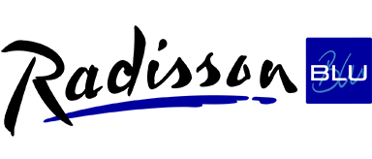

Check-in date |  | Check-out date
Credit card number (for hotel booking)*
Expiry Date (for hotel booking)*
Hotel Room Type
Standard Room

(+/- 100 € / night – breakfast included)

Standard Double Room

(+/- 120 € / night – breakfast included for 1 person, extra person 20 €)

Superior Room

(+/- 140 € / night – breakfast included for 1 person, extra person 20 €)

Junior Suite

(+/- 150 € / night – breakfast included for 1 person, extra person 20 €)

Only 5 rooms available

* Credit card details are asked to guarantee your room. Your credit card won’t be charged before the event. Payment processed at the check-out time.

Deadline for workshop registration: February 24th 2017

